Nice To Have Topics:

The history of Git

Important Topics:

Who uses Git?

Critical Topics:

What is Git?

Understanding difference between Git & GitHub

What does Git do for us?

WHAT EXACTLY GIT IS?

* Git is Version Control System
* Version control is software that tracks and manages changes to files over time.
* Version control is a system that records changes to a file or set of files over time so that you can recall specific versions later.
* Version control system generally allow users to revisit earlier versions of the files, compare changes between versions, undo changes, and a whole lot more
* Version Control System (VCS) is a very wise thing to use. It allows you to revert selected files back to a previous state, revert the entire project back to a previous state, compare changes over time, see who last modified something that might be causing a problem, who introduced an issue and when, and more. Using a VCS also generally means that if you screw things up or lose files, you can easily recover.
* Git is just one of the many version control systems available today. Other well-known ones include Subversion, CVS, and Mercurial.
* They all have similar goals, but vary significantly in how they achieve those goals.

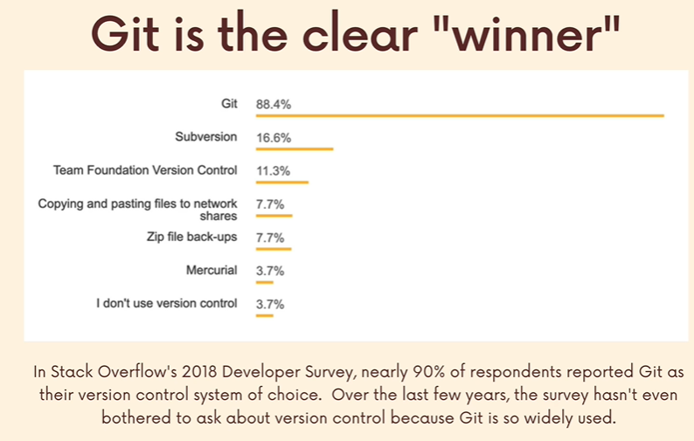

<https://git-scm.com/>

<https://git-scm.com/doc>

VISUALIZING GIT:

1. Track changes across multiple files
2. Compare versions of a project
3. “Time Travel” back to old versions
4. Revert to a previous version
5. Collaborate and share changes
6. Combines changes

If we screw things in current code or file we can revert back to last save point.

HISTORY OF GIT:

Linus Torvalds is the creator of git, he also main developer in creation Linux.

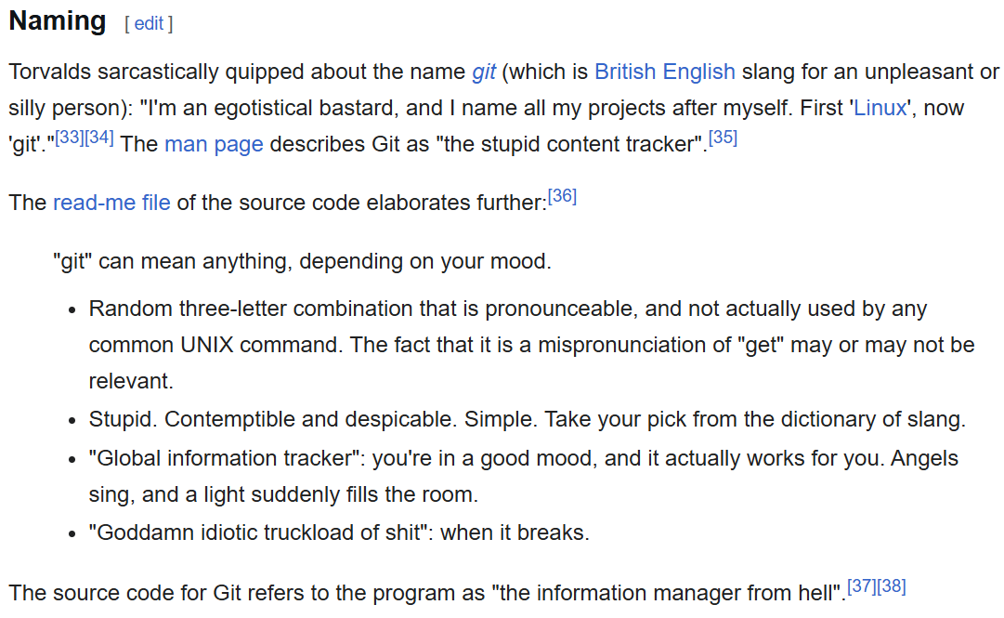

WHO USES GIT:

Engineers and coders

Tech-Adjacent Roles

Governments

Scientists

Writers

